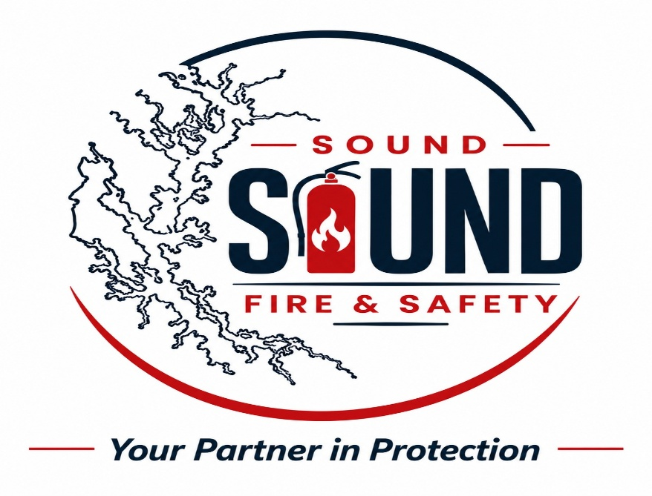

HOME
Sound Fire & Safety LLC is a Washington-based fire protection company committed to delivering reliable, code-compliant fire and life-safety solutions for residential, commercial, and industrial clients. Established in 2026 and headquartered in Bothell, Washington, the company provides high-quality fire safety services designed to protect people, property, and critical infrastructure.

ABOUT US
Who We Are
Sound Fire & Safety LLC operates as a Washington State Limited Liability Company, led by founder Abdoulie Lowe, who serves as the principal on record. The company is registered with the Washington Secretary of State and maintains an active status, reflecting its commitment to professional compliance and operational integrity.
Our mission is to deliver dependable fire-safety solutions that meet regulatory standards, reduce risk, and ensure peace of mind for building owners, contractors, and facility managers.

Our Services
Sound Fire & Safety LLC provides a range of fire-safety services designed to support safe building environments and regulatory compliance. While the company is distinct from specialized firestop inspection agencies, the broader fire-safety industry includes services such as:
- Fire Extinguisher Sales & Supply
- Fire Extinguisher Inspection & Servicing
- Safety training and consultation

SERVICES
Reliable, Code-Compliant Fire & Life Safety Solutions
Sound Fire & Safety LLC provides essential fire-safety services designed to protect lives, property, and business operations across Washington State. Our services support residential, commercial, and industrial environments, ensuring compliance, readiness, and peace of mind.
🔥 Fire Extinguisher Sales & Supply
High-quality, UL-listed fire extinguishers for every environment
We supply a full range of fire extinguishers suitable for homes, businesses, and industrial facilities. Our inventory includes:
- ABC Multi-Purpose Extinguishers
- CO₂ Extinguishers
- Class K (Kitchen) Extinguishers
- Vehicle & Marine Extinguishers
- Industrial & Specialty Units
Our team provides expert guidance on selecting the right extinguisher type, size, and placement to meet Washington State Fire Code and NFPA standards. Whether you need a single unit or bulk supply, we deliver durable, dependable equipment ready for emergency use.
Fire Extinguisher Inspection & Servicing
Annual inspections, maintenance, tagging, and compliance support
We ensure your fire extinguishers remain fully operational and compliant through professional servicing aligned with NFPA 10 guidelines. Our services include:
- Annual extinguisher inspections
- Pressure checks & condition assessments
- Tagging and certification
- Replacement of expired or damaged units
- Mounting, placement, and compliance guidance
Our inspection and servicing process helps businesses maintain safety readiness and meet regulatory requirements without unnecessary complexity.
Safety Training & Consultation
Practical fire-safety education for employees, homeowners, and facility teams
We provide hands-on training and expert consultation to strengthen fire-safety awareness and emergency preparedness. Our training covers:
- Proper fire extinguisher usage
- Emergency response awareness
- Evacuation readiness
- Workplace fire-safety best practices
- Hazard identification and prevention
Our consultation services help clients evaluate risks, improve safety procedures, and align with local fire-safety guidelines. We empower individuals and organizations to respond confidently and effectively during fire emergencies.

Add pictures if possible

Our Commitment to Safety
We believe fire safety is more than a requirement — it is a responsibility. Sound Fire & Safety LLC is committed to:
- Code Compliance: Ensuring all services align with Washington State and national fire-safety standards.
- Professional Integrity: Transparent operations and reliable service delivery.
- Customer Protection: Helping clients safeguard lives, assets, and business continuity.
- Quality Assurance: Delivering services with precision, consistency, and attention to detail.

MISSION
To provide reliable, code-compliant fire and life-safety services with integrity, precision, and consistent excellence.

VISION
To be Washington’s most trusted fire-safety partner, known for quality, compliance, and dependable protection for the communities we serve.

Core Value

Safety First
We prioritize the protection of lives and property in every decision, service, and inspection.

Integrity
We operate with honesty, transparency, and professionalism—earning trust through consistent, dependable work.

Quality & Compliance
We uphold strict standards aligned with Washington State and national fire-safety codes, ensuring every service meets regulatory requirements.

Reliability
Clients can count on us for timely, accurate, and thorough fire-safety support.

Contact Us
Address: 11400 Airport Rd, Suite 200, Everett, WA 98024
Phone: 4253502217 / 4253469231 / 4253509451
Email : info@.........
Working Hours: Monday to Friday, 8am–5pm

LEADERSHIP
Abdoulie Lowe – Chief Executive Officer
Abdoulie Lowe serves as the Chief Executive Officer of Sound Fire & Safety LLC, providing strategic leadership and operational oversight for the company’s fire-safety services across Washington State. As the founding principal, he guides the organization’s commitment to delivering reliable, code-compliant fire and life-safety solutions for residential, commercial, and industrial clients.
With a strong background in multi-sector operations and regulatory compliance, Abdoulie ensures that Sound Fire & Safety maintains the highest standards of quality, professionalism, and customer protection. His leadership emphasizes integrity, precision, and consistent service excellence—values that shape the company’s culture and drive its mission.
Abdoulie is dedicated to strengthening community safety through dependable fire-safety practices, modern service delivery, and a customer-focused approach. Under his direction, Sound Fire & Safety continues to grow as a trusted partner for building owners, contractors, and facility managers throughout Washington.

Haddy Saho – Chief Operating Officer
Haddy Saho serves as the Chief Operating Officer of Sound Fire & Safety LLC, overseeing daily operations, service coordination, and quality assurance across all fire-safety projects. With a strong background in healthcare operations and regulatory compliance, she brings a disciplined, detail-oriented approach to managing the company’s service delivery and customer support systems.
Haddy is known for her ability to blend operational precision with a strong commitment to safety and customer care. She ensures that all services meet Washington State fire-safety standards, supporting the company’s mission to provide reliable, code-compliant protection for homes, businesses, and facilities.
Her leadership strengthens Sound Fire & Safety’s operational efficiency, team performance, and service consistency. Through her guidance, the company continues to uphold high standards of professionalism, integrity, and dependable fire-safety solutions for clients across Washington.

Nixon Kwaku Duah Junior – Chief Strategy Officer
Nixon serves as the Chief Strategy Officer of Sound Fire & Safety LLC, guiding the company’s long-term strategic direction and organizational development. He leads the planning, analysis, and growth initiatives that strengthen the company’s position within Washington’s fire-safety industry.
With a strong background in strategic management and operational alignment, Nixon ensures that Sound Fire & Safety’s goals, services, and compliance standards remain forward-focused and competitive. His work includes evaluating market needs, shaping service expansion, and supporting the company’s commitment to reliable, code-compliant fire and life-safety solutions.
Nixon’s strategic leadership helps the company maintain clarity, consistency, and long-term stability—ensuring Sound Fire & Safety continues to grow as a trusted partner for homeowners, businesses, and facility managers across Washington.


Mass Lowe – Director of Operations
Mass Lowe serves as the Director of Operations for Sound Fire & Safety LLC, overseeing the company’s day-to-day service delivery, field coordination, and operational performance. He ensures that all fire-safety projects are executed efficiently, safely, and in full alignment with Washington State regulatory standards.
With a strong focus on workflow management, team leadership, and quality assurance, Mass plays a key role in maintaining the company’s operational consistency and customer satisfaction. His leadership strengthens internal processes, supports field readiness, and ensures that every service meets the company’s commitment to reliability and code-compliant fire and life-safety solutions.
Mass’s operational oversight helps Sound Fire & Safety deliver dependable, professional, and timely services to homeowners, businesses, and facility managers across Washington.

Why Choose Sound Fire & Safety LLC
At Sound Fire & Safety LLC, we deliver reliable, compliant, and customer-focused fire-safety solutions designed to protect lives, property, and business operations. Our commitment to excellence ensures that every client receives professional service, high-quality equipment, and dependable support.
1. Certified Quality You Can Trust
We provide industry-standard fire extinguishers and safety products that meet national fire-safety requirements. Every unit we sell is durable, dependable, and ready for emergency use.
2. Professional Inspection & Servicing
Our Fire Extinguisher Inspection & Servicing ensures your equipment remains fully operational and compliant. We offer annual inspections, maintenance, tagging, and replacement services with precision and care.
3. No-Hassle Compliance Support
We help businesses stay compliant with local fire-safety guidelines without the complexity. Our team ensures your extinguishers are properly placed, inspected, and maintained according to safety standards.
4. Expert Safety Training & Consultation
We provide practical, easy-to-understand safety training for employees, homeowners, and facility managers. From extinguisher usage to emergency response awareness, we equip you with the knowledge to act confidently in critical moments.
5. Fast, Reliable, and Customer-Focused Service
We pride ourselves on responsiveness. Whether you need new extinguishers, servicing, or safety guidance, our team delivers prompt, professional support tailored to your needs.
6. Local Company, Community Commitment
As a Washington-based business, we understand the needs of local homes, businesses, and facilities. We are committed to keeping our communities safe through accessible, affordable fire-safety solutions.
7. Transparent Pricing & Honest Recommendations
We believe in integrity. No upselling, no hidden fees — just clear, honest guidance and cost-effective fire-safety services.
Industries We Serve
- Residential Homes
- Commercial Buildings
- Retail Stores
- Restaurants
- Warehouses
- Healthcare Facilities
- Schools & Childcare Centers
- Industrial Sites
- Property Management Companies

Call-to-Action (CTA) Buttons
Add buttons throughout the site:
- Request Service
- Schedule Inspection
- Buy Extinguishers
- Contact Us Today

Certifications & Credentials (Even if basic)
- Washington State LLC Registration – This is ready
- Business License --- I will provide this when its ready

